Did Transforming Assessments in Large-Enrollment Introductory Statistics Impact Student Achievement? Surprisingly, Only for Those Who Needed It!
Wondering how to reach those students with lesser mathematical preparedness in introductory statistics courses? Using regression discontinuity methodology, large-enrollment introductory statistics courses were compared before and after implementing Formative Assessment Cycles (Hadfield, 2023). FACs (frequent formative assessments, automatic feedback, and the opportunity for reassessment) were implemented as a curricular intervention to address the call for improving student pathways for completing their introductory statistics requirement (Peck, 2019). The results showed meaningful differences in course achievement, specifically, that FACs helped students with less mathematical preparedness successfully navigate this quantitative requirement. In this poster, participants will see how co-requisite courses can benefit from FACs and how to implement them to improve student achievement.
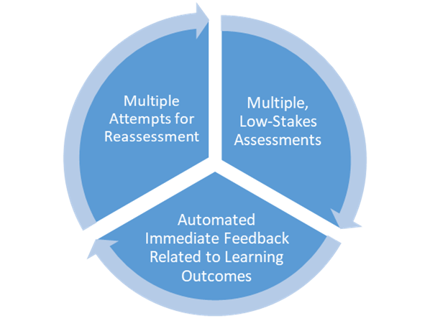
Implementing formative assessment in large-enrollment courses can be taxing, but the takeaway of the results of this study provides exciting developments in student achievement in introductory statistics using FACs, specifically for less mathematically prepared students. We will discuss the graphs from the analysis depicting the frog-pond effect (Hox, 2018) that may explain FACs' positive impact on this student demographic. The benefits and ways that FACs can be implemented will be provided, and my hope is that participants will be invigorated and empowered to implement co-requisite courses with formative assessments in their departments.
Figure 1 The formative assessment cycle

References:
Abell, M., Braddy, L., Ensley, D., Ludwig, L., & Soto, H. (2018). MAA instructional practices guide. Mathematical Association of America. https://www.maa.org/ programs-and communities/curriculum%20resources/instructional-practices-guide
American Statistical Association Revision Committee. (2016). Guidelines for assessment and instruction in statistics education (GAISE) college report. American Statistical Association. http://www.amstat.org/education/gaise
Cash, C. B., Letargo, J., Graether, S. P., & Jacobs, S. R. (2017). An analysis of the perceptions and resources of large university classes. CBE Life Sciences Education, 16(2), 1–12. https://doi.org/10.1187/cbe.16-01-0004
Chew, P., & Dillon, D. (2014). Statistics anxiety update: Refining the construct and recommendations for a new research agenda. Perspectives on Psychological Science, 9(2), 196–208. https://doi.org/10.1177/1745691613518077
Complete College America. (2012). Remediation: Higher education’s bridge to nowhere. https://completecollege.org/wp-content/uploads/2017/11/CCA-Remediation-final.pdf
Davies, N., & Marriott, J. (2010). Assessment and feedback in statistics. In P. Bidgood, N. Hunt, & F. Joliffe (Eds.), Assessment methods in statistical education: An international perspective (pp. 3–20). Wiley.
Dweck, C. S. (2008). Mindsets and math/science achievement. Carnegie Corporation of New York. http://www.growthmindsetmaths.com/uploads/2/3/7/7/23776169/ mindset_and_ math_science_achievement_-_nov_2013.pdf
Hadfield, K.F. (2023). A conceptual framework for formative assessment in large-enrollment introductory statistics. Statistics Education Research Journal, 22(1). https://iase-web.org/ojs/SERJ/article/view/99
Harlen, W. (2012). On the relationship between assessment for formative and summative purposes. In J. Gardner (Ed.), Assessment and learning (pp. 87–102). SAGE Publications. http://dx.doi.org/10.4135/9781446250808.n6
Hox, J., Moerbeek, M., & van de Schoot, R. (2018). Multilevel analysis: Techniques and applications. Routledge.
Peck, R. (2019). The evolving statistics pathway. In R. Hartzler & R. Blair (Eds.), Emerging issues in mathematics pathways case studies, scans of the field, and recommendations (pp. 33–40). Charles A. Dana Center at The University of Texas at Austin. https://tacc.org/sites/default/files/documents/2019-04/emerging-issues-in-mathematics-pathways.pdf#page=45
Simonite, V., & Targett, R. (2010). Assignments made in heaven? Computer-marked, individualised coursework in an introductory level statistics course. In P. Bidgood, N. Hunt, & F. Jolliffe (Eds.), Assessment methods in statistical education: An international perspective (pp. 235–246). Wiley.
Spencer, N. (2010). An adaptive, automated, individualised assessment system for introductory statistics. In P. Bidgood, N. Hunt, & F. Jolliffe (Eds.), Assessment methods in statistical education: An international perspective (pp. 211–222). Wiley.
Stirling, D. (2010). Random computer-based exercises for teaching statistical skills and concepts. In P. Bidgood, N. Hunt, & F. Jolliffe (Eds.), Assessment methods in statistical education: An international perspective (pp. 223–234). Wiley
Thistlewaite, D., & Campbell, D. (1960). Regression discontinuity analysis: An alternative to the ex post facto experiment. Journal of Educational Psychology, 51, 309–317. https://doi.org/10.1037/h0044319
Williams, A. (2015). Statistics anxiety and worry: The roles of worry beliefs, negative problem orientation, and cognitive avoidance. Statistics Education Research Journal, 14(2), 53–75. https://doi.org/10.52041/serj.v14i2.261

