eCOTS 2014 Handout
Valentine’s Day Marbles
A hotel holds a Valentine's Day contest where guests are invited to estimate the percentage of red marbles in a huge clear jar containing both red marbles and white marbles. There are 11,000 total marbles in the jar: 3,696 are red & 7,304 are white. The actual percentage of red marbles in the entire jar, 33.6%, is only known to some members of the hotel staff.
Any guest who makes an estimate that is within 9 percentage points of the true percentage of red marbles in the jar wins a prize, so any estimate from 24.6% to 42.6% will be considered a winner. To help with the estimating, a guest is allowed to take a random sample of 16 marbles from the jar in order to come up with an estimate. (Note: when this occurs, the marbles are then returned to the jar after counting.)
One of the hotel employees who does not know that the true percentage of red marbles in the jar is 33.6% is asked to record the results of the first 100 random samples. A table and dot plot of the results appears below.

Percentage of red marbles in the sample of size 16 | Number of times the percentage was obtained
12.50% | 4
18.75% | 8
25.00% | 15
31.25% | 22
37.50% | 20
43.75% | 12
50.00% | 12
56.25% | 4
62.50% | 2
68.75% | 1
Total: | 100

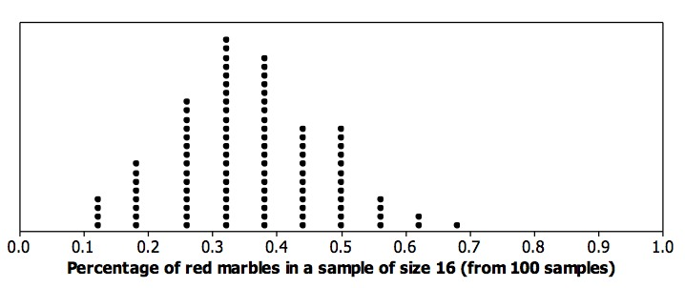
Should we be concerned that none of the samples had a red marble percentage of exactly 33.6% even though that value is the true red marble percentage for the whole jar? Explain your answer.

Mira Beach
In the town of Mira Beach, Florida the city council has taken a census of their population to get information about the city. The Town Census dataset contains information about every person in the population of Mira Beach. There are 1400 people that live in Mira Beach. The dataset contains information on the age, gender, race, marital status, school attendance, public or private school, and income of the residents of Mira Beach.
A. Given the approximate sampling distribution for the average income in the town of Mira Beach, what is a plausible value for the average income of people in Mira Beach? Justify your response, referring to your results from questions 1 & 2. If possible, give one other plausible value for the average income of people in Mira Beach and justify your response based on your results from questions 1 & 2. If it is not possible, explain why
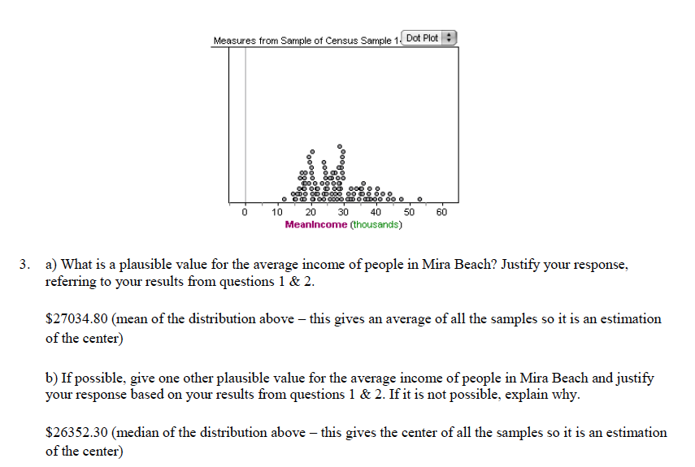
B. As part of a marketing campaign and among other standard pieces of information, the city council would like to know whether the students in the town consider their parents to be “strict.” They do not have time to collect this extra information from all the students in the town, so each city council member plans to obtain data from a sample of 30 students. The city council quickly realizes that, as there is no definition of “strict”, they could not simply ask a student, “Are your parents or guardians strict?” Write a question that could provide objective data to answer their question.

